**ASSIGNMENT 1.4**

**on**

**Docker**

**Submitted by:**

**Haseebullah Shaikh (2303.KHI.DEG.015)**

and

**Faiza Gulzar Ahmed (2303.khi.deg.001)**

**Dated :** 10th Apr 2023

**Task 01: Build an image based on Jupyter Notebook (jupyter/minimal-notebook) with Pandas installed (pip install pandas)**

Solution:

Created docker file, written commands for importing jupyter/minimal-notebook image and installing pandas library.

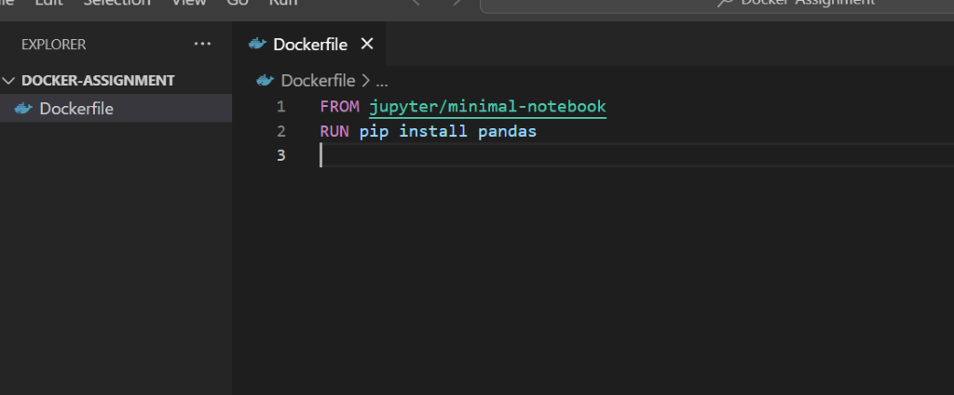

**Create a container from this image and use the NOTEBOOK_ARGS=--port=8889 environment variable to change the port Jupyter is exposed on**

Solution: Created container and changed the port.

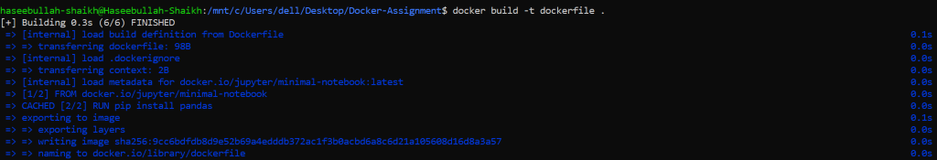

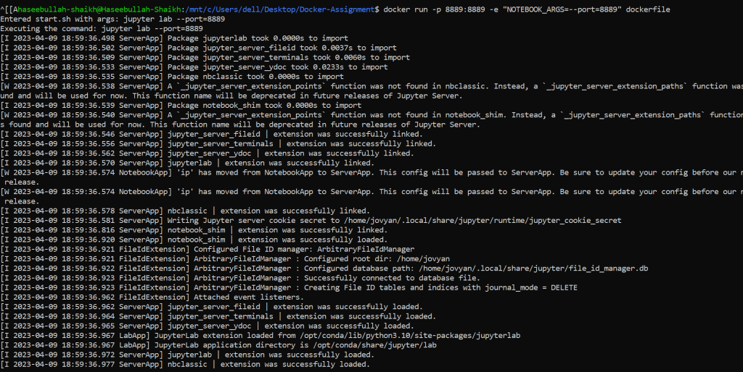



**Verify you can access it on port 8889 and that Pandas is installed (type import pandas in a notebook).**

Soultion : Verified and written a simple program using pandas

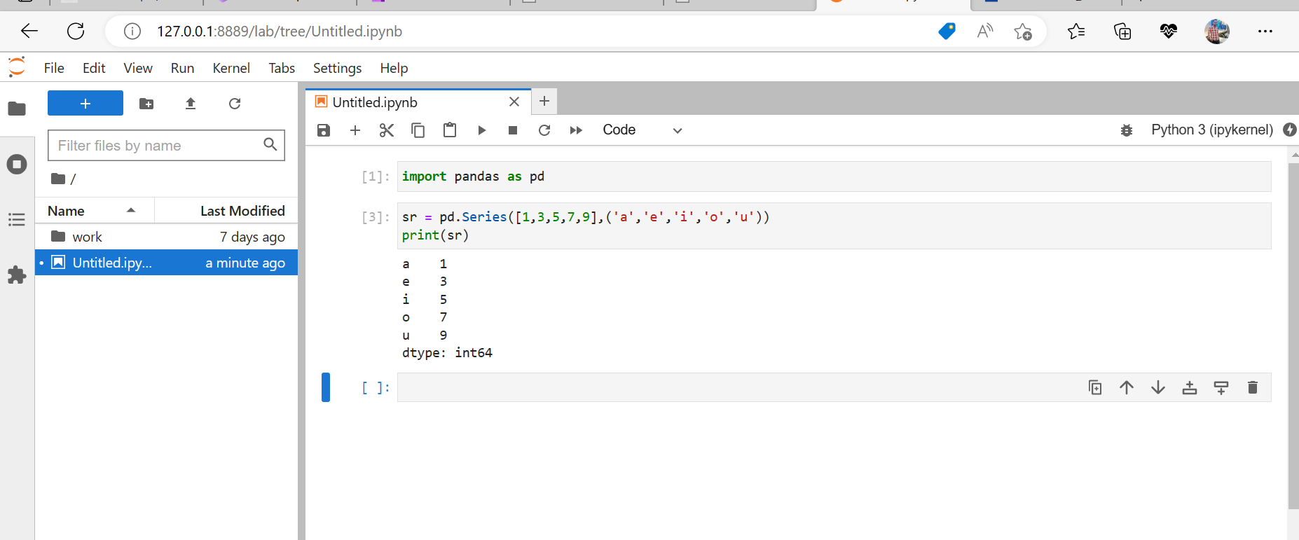

<---**The End**--->